Algebra 1: Unit 3, Lesson 3

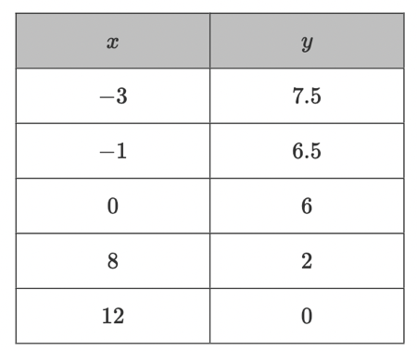
- The table of values shown represents a linear relationship.

What is the $y-$intercept of the linear relationship?

(0,6)

- The table of values shown represents a linear relationship.
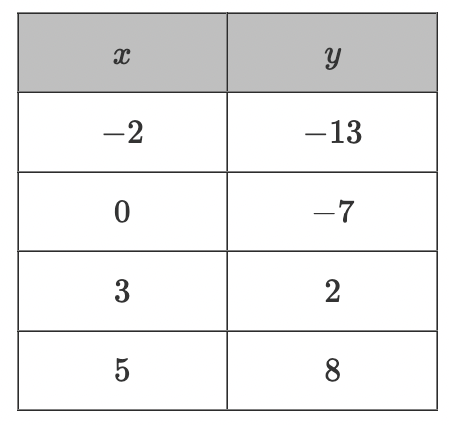
Charlie and Liam found the slope, $m$, of the linear relationship. Their work is shown.
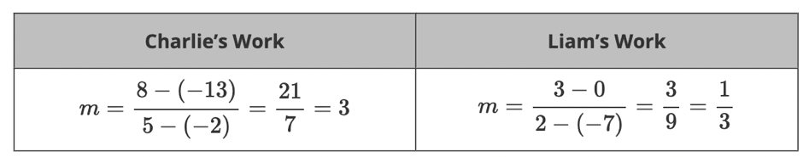
Who found the correct slope?
Charlie

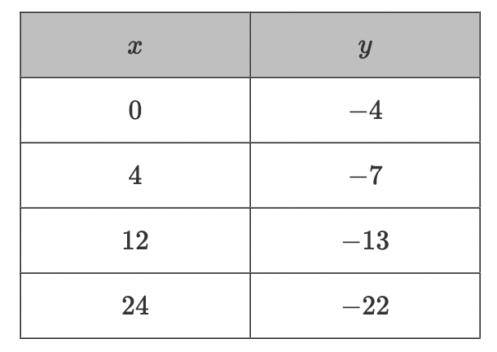
- The table of values represents a linear relationship.
What is the slope of the linear relationship?
$$-\frac{3}{4}$$

